**Advancing Nutrition Science Through GeminiAI**

*A Gen AI-powered initiative by Google Research*

A Research Project by Google Research – Health AI Division

Submitted by:

Ashutosh Gunjal

Palak Jethwani

Mohith P

Saiyam jain

Under the Guidance of: Sai Kiran

June 2025

**SmartInternz**

**Hyderabad, Telangana**

**Table of Contents**

|  |  |  |
| --- | --- | --- |
| **S. No.** | **INDEX** | **Page No.** |
| 1. | Acknowledgement | 4 |
| 2. | Executive Summary | 4 |
| 3. | Introduction | 4 |
| 4. | Project Overview | 5 |
| 5. | Literature Survey | 6 |
| 6. | Ideation and Brainstorming | 7 |
| 7. | Map and Canvas | 8 |
| 8. | Requirement Analysis | 9 |
| 9. | Project Design – Data Flow Diagrams | 11 |
| 10. | Technical Architecture | 12 |
| 11. | User Story | 13 |
| 12. | Scenarios – Feature Use Cases | 14 |
| 13. | Project Planning and Task Scheduling | 15 |
| 14. | Reports – Feature Summaries | 16 |
| 15. | Coding Explanation and Code Snippets | 16 |
| 16. | Training – Prompt Engineering | 20 |
| 17. | Testing | 20 |
| 18. | Advantages and Disadvantages | 21 |
| 19. | Output – User Interface | 22 |
| 20. | Future Scope | 29 |
| 21. | Conclusion | 29 |
| 22. | References | 30 |

**1. Acknowledgement**

We would like to express our sincere gratitude to our mentor for their invaluable guidance and support throughout this project. Their insights and encouragement played a pivotal role in shaping our understanding and execution of the work.

We are equally grateful to our institution and faculty for providing the resources and environment conducive to learning and innovation.

This project, *Advancing Nutrition Science Through GeminiAI*, would not have been possible without the combined efforts of our entire team. Each member contributed significantly, demonstrating dedication, creativity, and technical excellence.

We also acknowledge the use of powerful platforms and tools such as Google Gemini, Firebase, the USDA FoodData Central API, and open-source technologies like Flask and React, which collectively enabled us to bring this project to life.

**2. Executive Summary**

*Advancing Nutrition Science Through GeminiAI* is a collaborative initiative that leverages the capabilities of Generative AI to transform personal nutrition management. Our project, **NutriGen**, is an AI-driven web application designed to serve as a personal nutrition assistant, offering users personalized meal plans, detailed nutritional insights, and real-time virtual coaching.

The application combines data from the USDA FoodData Central API, secure user management via Firebase, and AI-powered responses using Google Gemini models. Built using a modern tech stack (Flask, React, Firebase, Tailwind), NutriGen ensures scalability, security, and user-friendliness.

Through tailored recommendations and interactive features, NutriGen empowers individuals to make informed dietary choices, promoting healthier lifestyles with AI as a constant companion. This project showcases the convergence of health science and advanced artificial intelligence in delivering real-world impact.

**3. Introduction**

NutriGen is a sophisticated, AI-driven web application engineered to serve as a personal nutrition assistant. The core mission of the project is to empower users to make informed and healthy dietary choices by leveraging the advanced capabilities of Google's Generative AI.

The application delivers a suite of tools including instant, comprehensive data on macronutrients (protein, fat, carbohydrates), micronutrients (vitamins, minerals), and caloric content for a vast array of food items. By offering features like tailored meal planning, dynamic nutritional analysis, and a virtual nutrition coach, NutriGen aims to make nutritional science accessible, understandable, and actionable for everyone.

**4. Project Overview**

This section outlines the foundational knowledge required for the project and provides a high-level view of its structural organization.

**4.1 Prior Knowledge**

To fully grasp the architecture and implementation of NutriGen, a foundational understanding of the following technologies is essential:

* **Backend Development:** Proficiency in Python and the Flask micro-framework is necessary to understand the server-side logic, API creation, and business rule implementation.
* **Frontend Development:** Knowledge of JavaScript/TypeScript, React, and the Vite build tool is crucial. Experience with state management using Redux Toolkit, routing with React Router, and styling with TailwindCSS is also required.
* **Database and Authentication:** Familiarity with Google Firebase, specifically Firestore (a NoSQL database) for data storage and Firebase Authentication for user management, is key.
* **API and AI Integration:** A basic understanding of RESTful API principles, JWT-based authentication, and the fundamentals of prompt engineering for interacting with large language models (LLMs) like Google Gemini is needed.

**4.2 Project Structure**

The project is organized into two main directories, client and server, representing a clear separation of concerns between the frontend and backend.

* **server/ (Backend):**
  + Built with **Flask**, this is the application's engine.
  + app.py: The main application file that defines all API endpoints for authentication, meal planning, nutrition insights, and AI chat.
  + firebase_config.py: Manages the connection to the Firebase Admin SDK and handles the creation and verification of custom JSON Web Tokens (JWTs) for secure communication.
  + AI/: This directory contains the logic for interacting with the Google Generative AI models.
    - mealPlanner.py: Generates personalized 7-day meal plans using a detailed, structured prompt.
    - chat.py: Powers the virtual coach, using user health data to provide tailored responses.
  + NutriInsights.py: A dedicated module for communicating with the external USDA FoodData Central API to fetch nutritional information.
* **client/ (Frontend):**
  + A modern single-page application (SPA) built with **React** and **Vite**.
  + src/pages/: Contains the main view components for each route, such as DashboardPage.jsx, MealPlannerPage.jsx, and VirtualCoachPage.jsx.
  + src/components/: Holds reusable UI elements like Button.jsx, Card.jsx, and Input.jsx.
  + src/app/: The core of the client-side state management, built with **Redux Toolkit**. It includes slices for authSlice.js, mealPlanSlice.js, etc., which manage application state and asynchronous API calls.
  + src/api/: Contains service modules (authService.js, mealPlanService.js, etc.) that use **Axios** to communicate with the Flask backend APIs.
  + src/routes/: Manages application navigation with AppRoutes.jsx, defining public and private routes.

**5. Literature Survey**

**5.1 Existing Problem**

Modern lifestyles present significant challenges to maintaining a healthy diet. The primary issues identified are:

* **Complexity of Meal Planning:** Many individuals struggle to create healthy, satisfying, and varied meal plans that align with their specific dietary needs, allergies, health conditions, and taste preferences. This often leads to repetitive, nutritionally imbalanced diets.
* **Lack of Nutritional Transparency:** While understanding the nutritional content of food is crucial for making healthy choices, this information is often inaccessible or difficult to interpret. Consumers need a simple way to get detailed information about macronutrients, micronutrients, and calories for their meals.
* **High Cost of Expert Guidance:** Access to personalized advice from a certified nutritionist is often expensive and time-consuming, placing it out of reach for many. This creates a barrier for individuals seeking to improve their health through diet.

**5.2 Proposed Solution**

NutriGen is designed to directly address these challenges by leveraging AI to provide a cost-effective, accessible, and personalized solution.

* **Tailored Meal Planning:** The application generates a complete seven-day meal plan, including recipes and grocery lists, based on a user's detailed profile. The AI ensures the plan is nutritionally balanced, enjoyable, and respects all user-specified restrictions.
* **Dynamic Nutritional Insights:** NutriGen provides instant nutritional breakdowns for any food item. Users can search for foods and receive detailed information, empowering them to make conscious decisions and track their intake against their health goals.
* **Virtual Nutrition Coaching:** The application democratizes access to nutritional expertise through an AI-powered virtual coach. This interactive feature provides personalized advice, answers questions, and offers support, helping users stay motivated and achieve long-term health improvements.

**6. Ideation and Brainstorming**

The core idea behind NutriGen was to create a single, unified platform that addresses the primary friction points in personal nutrition management. The brainstorming process centered on a few key principles:

* **Personalization as a Priority:** Generic advice is less effective. The platform had to be built around the user's unique profile, including their physical attributes, lifestyle, goals, and allergies. This led to the detailed registration process.
* **AI as the Engine:** To provide deep personalization at scale, Generative AI was chosen as the core technology. Instead of rule-based systems, an LLM could handle complex, nuanced user requirements for both meal planning and conversational coaching.
* **Data-Driven Insights:** To be credible, the application needed to be backed by reliable data. The USDA FoodData Central database was selected as the source for all nutritional information.
* **Seamless User Experience:** The interface needed to be intuitive and engaging. This led to the design of distinct sections for the Dashboard, Meal Planner, Insights, and Coach, all accessible from a clean navigation bar. Features like a meal-logging streak were added to encourage consistent user engagement.

**7. Map and Canvas**

**7.1 User Flow Map**

The user's journey through the application is structured logically, as defined by the application's routes.

1. New User

- Landing Page → Register Page (fills out profile and credentials) → Dashboard (upon successful registration)

2. Returning User

- Landing Page → Login Page → Dashboard

3. Authenticated User Journey

From the Dashboard, the user can:

- Log a meal to update their streak

- Navigate to the Meal Planner to generate or view their weekly plan

- Navigate to Insights to search for food nutrition data

- Navigate to the Virtual Coach for AI-powered advice

- Navigate to their Profile to view their health details

> All private routes are protected and will redirect to Login if the user is not authenticated.

|  |
| --- |
| 7.2 Lean Canvas |
| |  |  |  |  | | --- | --- | --- | --- | | **Problem** | **Solution** | **Key Metrics** | **Unique Value Proposition** | | 1. Meal planning is difficult and time-consuming.&lt;br>2. Nutritional information is hard to access.&lt;br>3. Expert advice is expensive. | An AI-powered web app providing:&lt;br>1. Personalized meal plans.&lt;br>2. Instant food nutrition analysis.&lt;br>3. 24/7 virtual coaching. | - User engagement (daily active users)&lt;br>- Meal plan generation rate&lt;br>- Number of food lookups&lt;br>- Meal logging streak length | Your all-in-one AI nutrition assistant. Get hyper-personalized meal plans, instant food insights, and 24/7 coaching to achieve your health goals effortlessly. | | **Unfair Advantage** | **Channels** | **Customer Segments** | **Cost Structure & Revenue** | | - Advanced prompt engineering for highly tailored outputs.&lt;br>- Integration of user data into a single, cohesive AI context.&lt;br>- Use of a reliable, comprehensive food database (USDA). | - Web application (direct access)&lt;br>- Search engine optimization (organic traffic)&lt;br>- Social media marketing | - Health-conscious individuals&lt;br>- People with specific dietary goals (weight loss, muscle gain)&lt;br>- Users with dietary restrictions (allergies, vegetarian) | **Cost:** Server hosting, external API fees (Google AI, USDA).&lt;br>**Revenue:** (Currently free) Potential for premium subscription model. | |

## ****8. Requirement Analysis****

### ****8.1 Functional Requirements****

* **F1. User Authentication:**  
  Users must be able to register with their credentials and a detailed health profile. They must be able to log in and log out. The system must keep users logged in across sessions.
* **F2. Secure Access:**  
  All user-specific data and features must be protected and accessible only after successful authentication.
* **F3. Profile Management:**  
  Users must be able to view their registered name, email, and health details on a profile page.
* **F4. Meal Plan Generation:**  
  The system must generate a personalized 7-day meal plan based on the user's stored health profile.
* **F5. Meal Plan Viewing:**  
  Users must be able to view their generated meal plan, organized by day and meal type.
* **F6. Food Nutrition Search:**  
  Users must be able to search for any food item and receive a list of matching results from the USDA database.
* **F7. Detailed Food Analysis:**  
  Users must be able to select a food item from the search results to view its detailed nutritional information, including macronutrients and micronutrients, presented with a pie chart.
* **F8. Virtual Coaching:**  
  Users must be able to have a text-based conversation with an AI nutrition coach. The chat must support conversation history.
* **F9. Meal Logging & Streak:**  
  Users must be able to log that they've eaten a meal for the day. The system must track and display their daily logging streak.
* **F10. Theme Personalization:**  
  Users must be able to toggle between light and dark themes to enhance comfort and accessibility during app usage.

### ****8.2 Non-Functional Requirements****

* **NF1. Security**  
  JWT-based authentication must secure APIs. Sensitive data (API keys, credentials) must be stored in environment variables and protected using best practices.
* **NF2. Performance**  
  The system must be responsive. API calls and AI processing should run asynchronously with loading indicators. Data must be cached when possible.
* **NF3. Usability**  
  The user interface must be clean, intuitive, responsive, and mobile-friendly. Accessibility standards (like color contrast and keyboard navigation) must be met.
* **NF4. Reliability**  
  The system must gracefully handle network failures, timeouts, and exceptions with clear, user-friendly error messages.
* **NF5. Scalability**  
  The app should handle increasing numbers of users without degradation. Firebase Firestore and Functions must be used efficiently to scale horizontally.
* **NF6. Maintainability**  
  The codebase should follow modular design, with clear separation of concerns and documentation for ease of future updates.
* **NF7. Compatibility**  
  The app should work across modern browsers (Chrome, Firefox, Safari, Edge) and be tested on different screen sizes.
* **NF8. Internationalization (i18n)**  
  The app should be prepared to support multiple languages and localization formats (dates, units, etc.).
* **NF9. Analytics Support**  
  The system should log user activity (meal generation, searches, streaks) for analytics, while maintaining data privacy.
* **NF10. Backup & Recovery**  
  Cloud Firestore's backup features should be used to ensure user data can be recovered in the event of failure or corruption.

**9. Project Design - Data Flow Diagrams**

**Level 0: Context Diagram**

This diagram shows the overall context of the NutriGen system, with the user as the primary external entity.

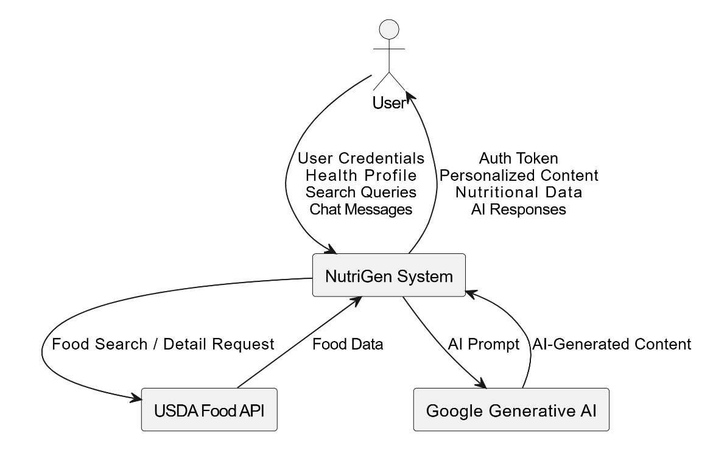

**Level 1: Data Flow Diagram**

This diagram breaks down the NutriGen system into its major processes.

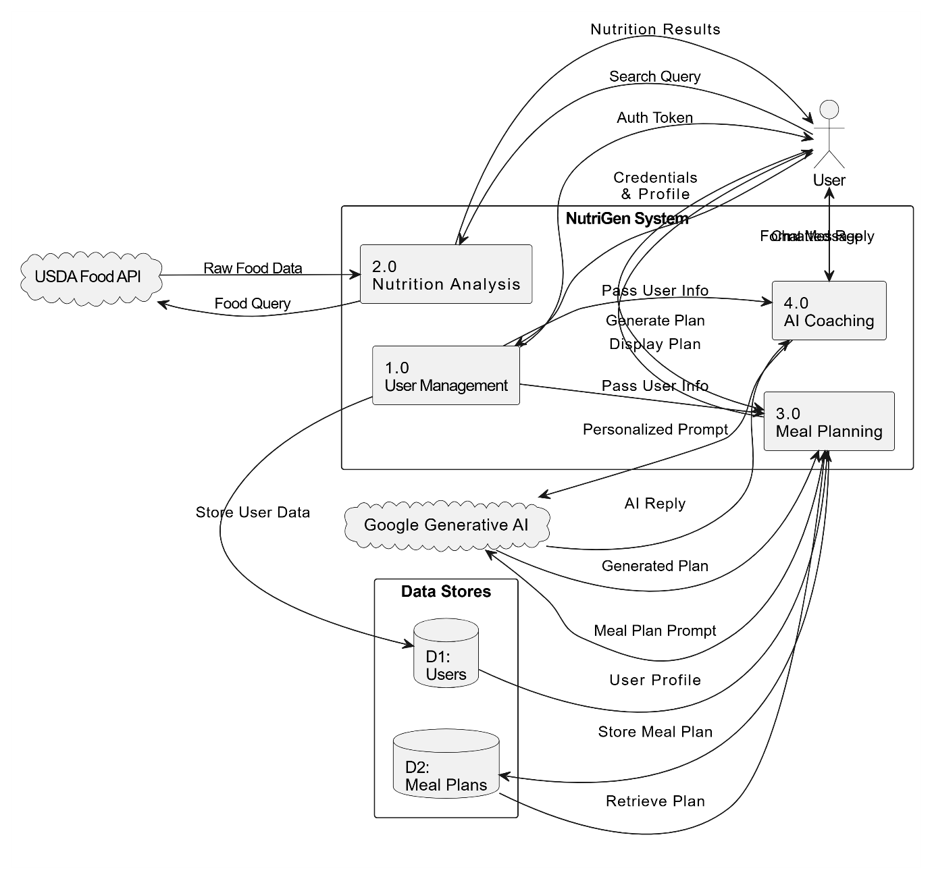

**10. Technical Architecture**

The NutriGen application is built on a modern, decoupled architecture with a React frontend and a Flask backend.

* **Frontend (Client):**
  + **Framework:** **React 18** with **Vite** as the build tool for a fast development experience.
  + **State Management:** **Redux Toolkit** is used for centralized and predictable state management. It simplifies API calls and caching logic with createAsyncThunk.
  + **Routing:** **React Router v6** manages client-side navigation, including protected routes for authenticated users.
  + **Styling:** **TailwindCSS** provides a utility-first CSS framework for rapid UI development. A custom theme is defined in tailwind.config.js for brand consistency. Dark mode is supported via a ThemeContext.
  + **API Communication:** **Axios** is used for making HTTP requests to the backend, with an interceptor configured to automatically attach the JWT authorization header to protected requests.
  + **Animations:** **Framer Motion** is used to add fluid animations and transitions, enhancing the user experience.
* **Backend (Server):**
  + **Framework:** **Flask**, a lightweight Python web framework, serves the REST API.
  + **Authentication:** A custom token-based authentication system is implemented. On login/register, a **JWT** is generated using the PyJWT library and a secret key. This token is then required for accessing protected API endpoints, where it is verified by a custom @requires_auth decorator.
  + **Database:** **Google Firestore** is used as the NoSQL database, accessed via the firebase-admin SDK. It stores user documents (containing profiles and health details) and meal plans.
  + **AI Integration:** **LangChain** and the langchain-google-genai library provide a high-level interface to communicate with Google's Gemini models. The backend constructs detailed prompts, sends them to the AI, and parses the JSON or text response.
  + **External APIs:** The requests library is used to interact with the **USDA FoodData Central API** for fetching nutritional information.
  + **Deployment:** The application is configured to run with Gunicorn, a production-ready WSGI server. CORS is handled by the Flask-Cors extension to allow requests from the frontend domain.

**11. User Story**

* **As a new user**, I want to register with my health details (age, weight, goal, allergies) so that the application can provide me with personalized nutritional advice and meal plans.
* **As a busy professional**, I want to generate a 7-day vegetarian meal plan for muscle gain so that I can shop and cook efficiently without having to plan every meal myself.
* **As a health-conscious individual**, I want to quickly search for "1 cup of quinoa" to understand its nutritional content so I can make an informed decision about my lunch.
* **As a user trying to lose weight**, I want to ask the virtual coach, "What are some healthy low-calorie snack options?" so I can get instant ideas without consulting a professional.
* **As a user building a new habit**, I want to log my meals daily and see my progress streak so that I stay motivated on my health journey.

**12. Scenarios - Feature Use Cases**

### Scenario 1: Tailored Meal Planning

Many individuals struggle with creating healthy and satisfying meal plans that align with their specific needs and preferences. NutriGen addresses this challenge by generating personalized meal plans based on user input such as dietary restrictions, allergies, health conditions, activity levels, and taste preferences. The AI then crafts a week-long meal plan with recipes and grocery lists, ensuring nutritional balance, variety, and enjoyment.

### Scenario 2: Dynamic Nutritional Insights

Understanding the nutritional content of food is essential for making healthy choices. NutriGen provides users with dynamic nutritional insights about their meals and snacks. By inputting food items or scanning barcodes, users can instantly receive detailed information about macronutrients (protein, fat, carbohydrates), micronutrients (vitamins, minerals), and calorie content. This empowers users to make conscious decisions about their food intake and track their progress toward nutritional goals.

### Scenario 3: Virtual Nutrition Coaching

Receiving personalized guidance from a nutrition expert can be costly and time-consuming. NutriGen democratizes access to nutritional expertise by offering virtual nutrition coaching. The AI acts as a virtual coach, providing users with personalized advice, answering questions, and offering ongoing support throughout their wellness journey. This interactive coaching experience helps users stay motivated, make sustainable lifestyle changes, and achieve long-term health improvements.

**13. Project Planning & Task Scheduling**

This table outlines a possible division of labor for the project's development.

|  |  |  |  |
| --- | --- | --- | --- |
| **Phase** | **Task** | **Team Member** | **Status** |
| **1. Setup & Design** | Initialize project structure, set up Git, design database schema. | Team Lead | Completed |
|  | Design UI/UX mockups and define component library. | Frontend Dev | Completed |
| **2. Backend Dev** | Implement Firebase integration and authentication (register, login, JWT). | Backend Dev | Completed |
|  | Create API endpoints for meal plan generation and retrieval. | Backend Dev | Completed |
|  | Implement AI prompt engineering for the meal planner and chat coach. | Backend Dev | Completed |
|  | Develop USDA API integration for nutrition search. | Backend Dev | Completed |
|  | Implement streak and meal logging logic and endpoints. | Backend Dev | Completed |
| **3. Frontend Dev** | Set up Redux store and slices (auth, mealPlan, coach). | Frontend Dev | Completed |
|  | Build core UI components (Button, Card, Input) and layout (Navbar, Footer). | Frontend Dev | Completed |
|  | Develop authentication pages (Login, Register) with form handling. | Frontend Dev | Completed |
|  | Build Dashboard, Meal Planner, Insights, and Coach pages. | Frontend Dev | Completed |
| **4. Integration & Test** | Connect frontend components to backend APIs via Redux thunks. | Full Stack | Completed |
|  | Write unit tests for backend logic and API endpoints. | Backend Dev | Completed |
|  | Perform manual end-to-end testing of all user stories. | QA/Team | Completed |
| **5. Deployment** | Configure server for production (Gunicorn, environment variables). | Team Lead | Completed |
|  | Deploy frontend and backend to a hosting service (e.g., Render, Vercel). | Team Lead | Completed |

**14. Reports - Feature Summaries**

* **Landing Page:** Serves as the marketing front door, outlining the app's value proposition with clear calls-to-action for registration and login.
* **Dashboard:** The user's home base after logging in. It displays a welcome message, a meal-logging streak tracker to encourage engagement, and quick-action cards to navigate to the main features.
* **Meal Planner Page:** Allows users to generate a new 7-day meal plan with a single click. It presents the plan in a clean, day-by-day view with a summary of total daily nutritional values.
* **Insights Page:** A powerful tool for on-demand nutritional information. Users can search for any food, select from a list of results, and view a detailed breakdown of its macro- and micronutrients, complete with a visual pie chart.
* **Virtual Coach Page:** An interactive chat interface where users can ask nutrition-related questions. It maintains conversation history and provides helpful, context-aware answers based on the user's profile.
* **Registration Page:** A comprehensive form that collects not only user credentials but also all the necessary health details (age, weight, goals, allergies) required for personalization.

**15. Coding Explanation & Code Snippets**

**15.1 Backend**

**1. Secure API Endpoint with a Decorator (app.py)**

This decorator ensures that only authenticated users with a valid JWT can access certain routes. It checks for the Authorization header, splits out the bearer token, and verifies it using the function from firebase_config.py.

Python:

# v2 finale/server/app.py

def requires_auth(f):

    @wraps(f)

    def decorated(*args, **kwargs):

        auth_header = request.headers.get('Authorization')

        if not auth_header or not auth_header.startswith('Bearer '):

            raise AuthError({

                'code': 'authorization_header_missing',

                'description': 'Authorization header is expected.'

            }, 401)

        token = auth_header.split(' ')[1]

        try:

            payload = verify_custom_token(token)

            request.current_user = payload

        except Exception as e:

            raise AuthError({

                'code': 'invalid_token',

                'description': 'The token is invalid or expired.'

            }, 401)

        return f(*args, **kwargs)

    return decorated

@app.route('/api/me', methods=['GET'])

@requires_auth

def get_current_user():

    # This route is now protected

    user_id = request.current_user['uid']

    # ...

**2. AI Prompt Engineering for Meal Plans (AI/mealPlanner.py)**

This snippet shows the detailed prompt used to instruct the Gemini model. It includes placeholders for user data, a clear explanation of the required calculations (BMR), and a strict definition of the desired JSON output format. This ensures the AI's response is structured and predictable.

Python:

# v2 finale/server/AI/mealPlanner.py

def generate_meal_plan(name, age, gender, height, weight, diet_preference, goal, activity_level, allergies):

    prompt = f"""

You are a certified AI nutritionist.

Your task is to create a personalized 7-day meal plan... based on the following input:

- Name: {name}

- Age: {age}

- Gender: {gender}

# ... other user details ...

- Calories: Calculate the ideal daily calorie intake using this logic:

   - **Base Calories (BMR estimate)**:

     - Male: `10 × {weight} + 6.25 × {height} - 5 × {age} + 5`

     - Female: `10 × {weight} + 6.25 × {height} - 5 × {age} - 161`

# ... other instructions ...

STRICT JSON STRUCTURE (required):

{{

  "mealPlan": {{

    "Sunday": {{

      "Breakfast": {{

        "name": "", "ingredients": "", "portionSize": "",

        "calories": 0, "protein": 0, "carbs": 0, "fat": 0

      }},

      ...

    }}

  }}

}}

DO NOT:

- Include markdown

- Include explanations

"""

    # ... model invocation ...

    return response

**15.2 Frontend**

**1. Asynchronous Authentication with Redux (app/features/authSlice.js)**

This async thunk handles the user login process. It calls the authService, and upon a successful response, it updates the application state to mark the user as authenticated and stores their data. Redux Toolkit automatically handles the pending, fulfilled, and rejected action types.

JavaScript:

// v2 finale/client/src/app/features/authSlice.js

import { createSlice, createAsyncThunk } from '@reduxjs/toolkit';

import authService from '../../api/authService';

export const login = createAsyncThunk(

  'auth/login',

  async ({ email, password }, { rejectWithValue }) => {

    try {

      const { user } = await authService.login(email, password);

      return { user };

    } catch (error) {

      return rejectWithValue(error.message || 'Login failed');

    }

  }

);

// ... in extraReducers

builder

  .addCase(login.pending, (state) => {

    state.isLoading = true;

    state.error = null;

  })

  .addCase(login.fulfilled, (state, action) => {

    state.isLoading = false;

    state.isAuthenticated = true;

    state.user = action.payload.user;

  })

  // ...

**2. Handling User Input and API Calls (pages/InsightsPage.jsx)**

This function from the Insights page demonstrates how the frontend captures user input, sets a loading state, calls the nutrition search API, and handles the response or error.

JavaScript:

// v2 finale/client/src/pages/InsightsPage.jsx

const handleSearchSubmit = async (e) => {

  e.preventDefault();

  if (!query.trim()) return;

  setIsLoading(true);

  setError(null);

  try {

    const results = await searchFoodAPI(query.trim()); // API call

    setSearchResults(results);

  } catch (err) {

    setError(err.message);

    setSearchResults([]);

  } finally {

    setIsLoading(false);

  }

};

**16. Training - Prompt Engineering**

In the context of NutriGen, AI "training" is not about fine-tuning a model but about **expert prompt engineering**. The application's intelligence is derived from crafting highly detailed and structured prompts that guide the pre-trained Google Gemini models to produce the desired output.

The most prominent example is in the mealPlanner.py module. The prompt is engineered with several key components:

1. **Role-Playing:** The prompt begins by assigning a role to the AI: "You are a certified AI nutritionist". This sets the context and tone for the response.
2. **Explicit Instructions:** The task is clearly defined: "create a personalized 7-day meal plan".
3. **Data Injection:** User-specific data (age, weight, goal, etc.) is dynamically inserted into the prompt using f-strings.
4. **In-Prompt Logic:** The AI is given the exact formulas to calculate the user's daily calorie needs based on their BMR, activity level, and goals. This offloads complex calculations to the LLM and ensures the plan is based on scientific principles.
5. **Strict Output Formatting:** The prompt demands the output be "pure JSON" and provides a precise, non-negotiable schema. This is critical for the backend to reliably parse the AI's response and save it to the database.
6. **Negative Constraints:** The prompt explicitly states what *not* to do (e.g., "Do not include markdown", "Do not include explanations"), which prevents the AI from adding conversational fluff that would break the JSON parsing.

A similar, though simpler, approach is used in chat.py, where the user's health profile is prepended to the chat history to give the AI context for personalized, conversational replies.

**17. Testing**

While automated test files were not included, a robust testing strategy for this project would involve the following layers:

* **Backend Testing:**
  + **Unit Tests:** Using a framework like pytest to test individual functions, such as the BMR calculation logic or the parsing functions in NutriInsights.py.
  + **Integration Tests:** Testing the interaction between different backend components, such as ensuring the /generate-meal-plan route correctly fetches user data from Firestore before calling the AI service.
  + **API Endpoint Tests:** Using a tool like Postman or writing test scripts to call each API endpoint (/login, /register, /me, etc.) with valid and invalid data/tokens to verify correct responses, status codes, and error handling.
* **Frontend Testing:**
  + **Component Tests:** Using a framework like React Testing Library to render individual components (e.g., Button, Card) and assert that they display correctly and respond to user interaction.
  + **Integration Tests:** Testing how multiple components work together. For example, testing the LoginPage to ensure that clicking the "Sign In" button dispatches the correct Redux action.
  + **End-to-End (E2E) Tests:** Using a tool like Cypress or Playwright to simulate a full user journey, such as registering, logging in, generating a meal plan, and logging out.
* **Manual Testing Use Cases:**
  + **Registration:** Attempt to create an account with a password that does not match the confirmation. Verify that an error is shown.
  + **Authentication:** Log in with correct credentials and confirm navigation to the dashboard. Log out and try to access /dashboard directly, verifying a redirect to /login.
  + **Meal Planner:** For a user with a "gluten" allergy, generate a meal plan and manually inspect the results to ensure no gluten-containing ingredients (like wheat) are present.
  + **Insights:** Search for a common food like "banana" and verify results are displayed. Click a result and confirm the nutrition details and pie chart load correctly.

**18. Advantages and Disadvantages**

**Advantages**

* **Hyper-Personalization:** The use of Generative AI allows for a level of personalization in meal planning and coaching that is difficult to achieve with traditional software.
* **Cost-Effective:** NutriGen provides services that are analogous to those of a professional nutritionist but at a fraction of the cost, making it highly accessible.
* **24/7 Availability:** The AI coach and other tools are available anytime, providing instant support whenever the user needs it.
* **All-in-One Platform:** It consolidates multiple health tools (meal planner, nutrition database, coach) into a single, cohesive application.
* **Engaging User Experience:** Features like the meal-logging streak, interactive charts, and a clean UI are designed to keep users motivated and engaged.

**Disadvantages**

* **AI Reliability:** As with any LLM, the AI's responses can occasionally be generic, factually incorrect, or may require regeneration to get the best result. It does not replace professional medical advice.
* **API Dependency:** The application's core functionality is heavily dependent on external services (Google AI, USDA API). Any downtime, rate limiting, or cost changes from these services would directly impact NutriGen.
* **Data Accuracy:** The accuracy of the nutritional data is entirely dependent on the quality of the data provided by the USDA API.
* **Lack of Professional Oversight:** While the AI is powerful, it lacks the nuanced judgment and accountability of a certified human nutritionist, which is critical for users with serious medical conditions.

**19. Output - User Interface**

The user interface is designed to be clean, modern, and intuitive, with key information presented in visually appealing cards and charts.

* **Landing Page:** The first point of contact for users, it effectively communicates the app's value through bold typography, benefit lists, and feature cards.

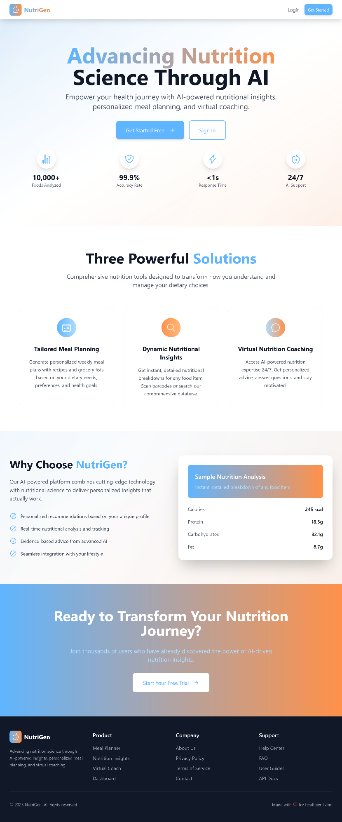

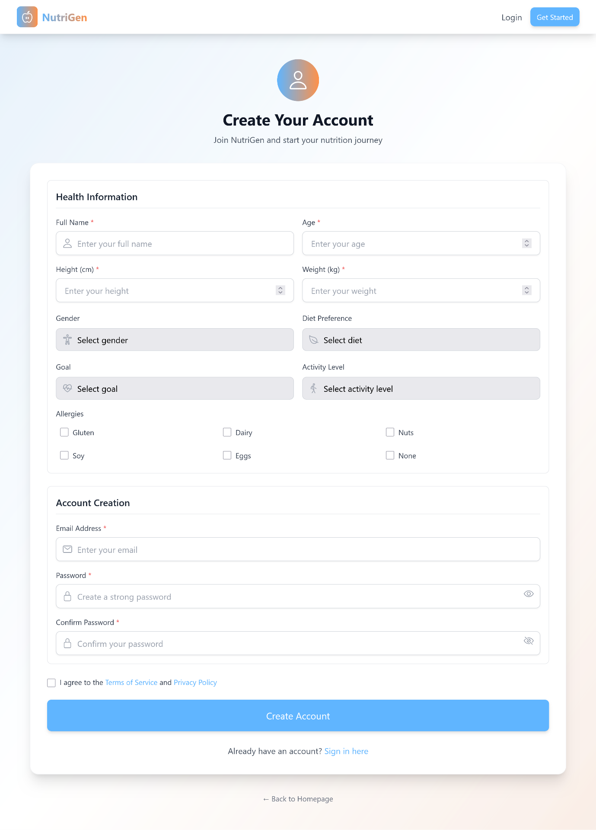

* **Dashboard Page:** Upon logging in, the user is greeted with a personalized welcome message. The central features are a card displaying their current meal-logging **streak** and quick-action cards that provide easy navigation to the main sections of the app.

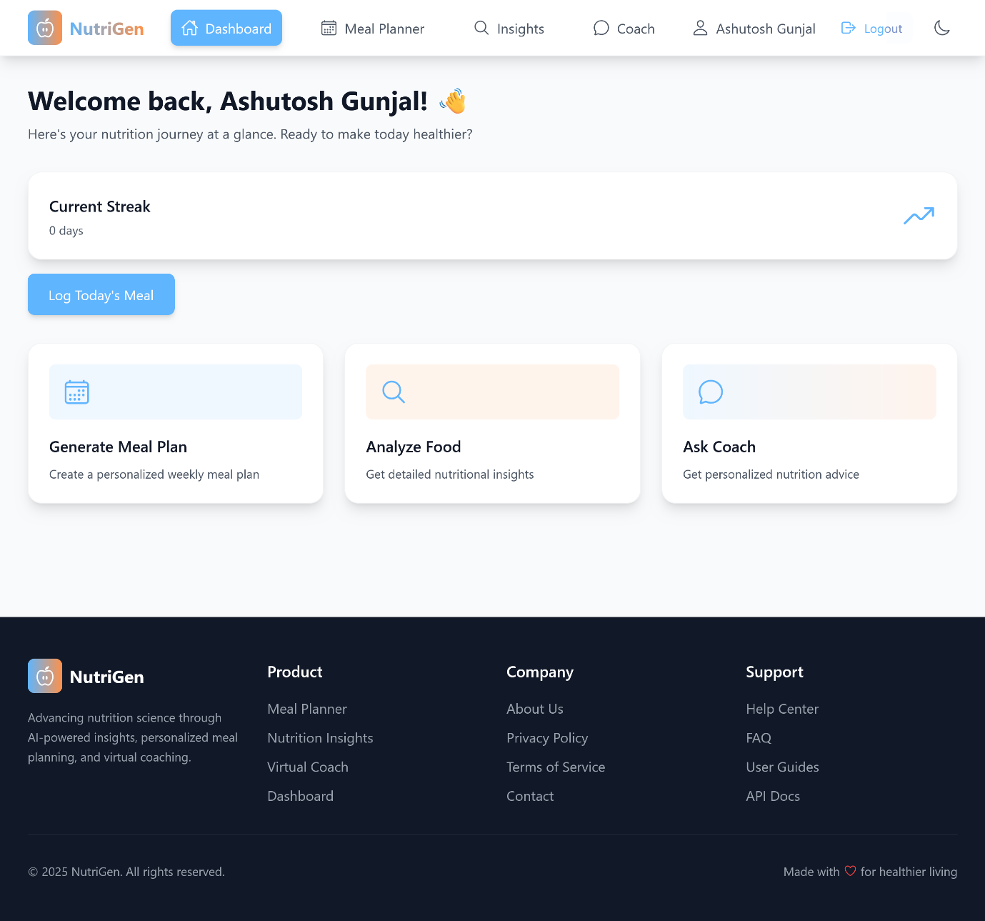

* **Insights Page:** This page features a prominent search bar. After a search is performed, results are displayed in a grid of cards. Clicking a result transitions the view to a detailed analysis, which includes a **nutrition pie chart** for macronutrients and a list of micronutrients, providing a comprehensive overview at a glance.

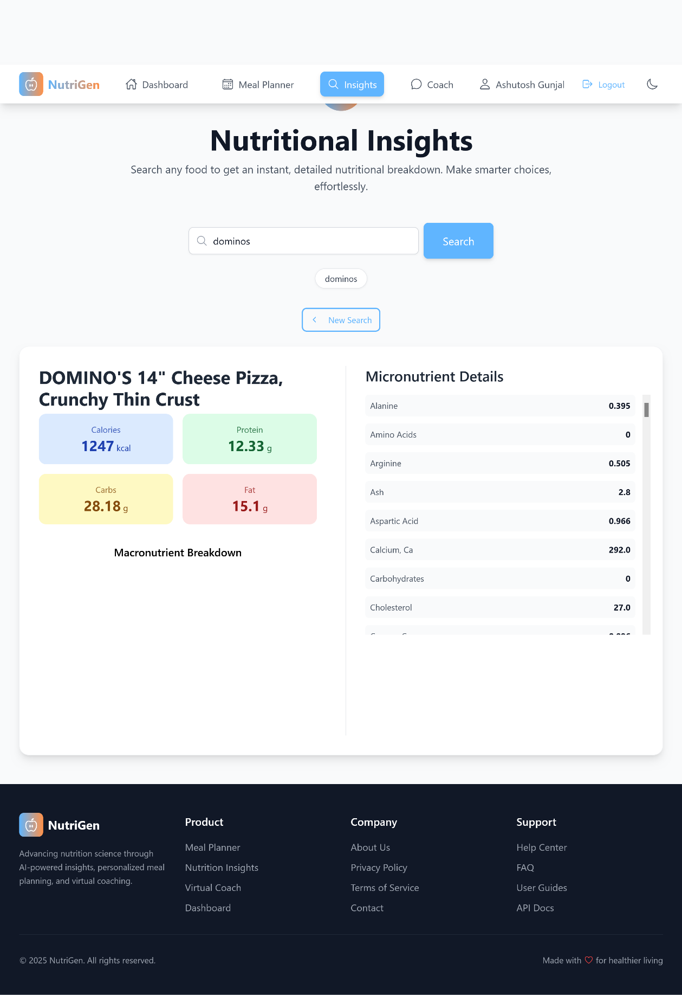

* **Meal Planner Page:** This page features a horizontal day selector, allowing the user to switch between days of the week. For the selected day, it shows a summary of total calories and macros, followed by individual cards for Breakfast, Lunch, Dinner, and Snack, each detailing the meal's name and ingredients.

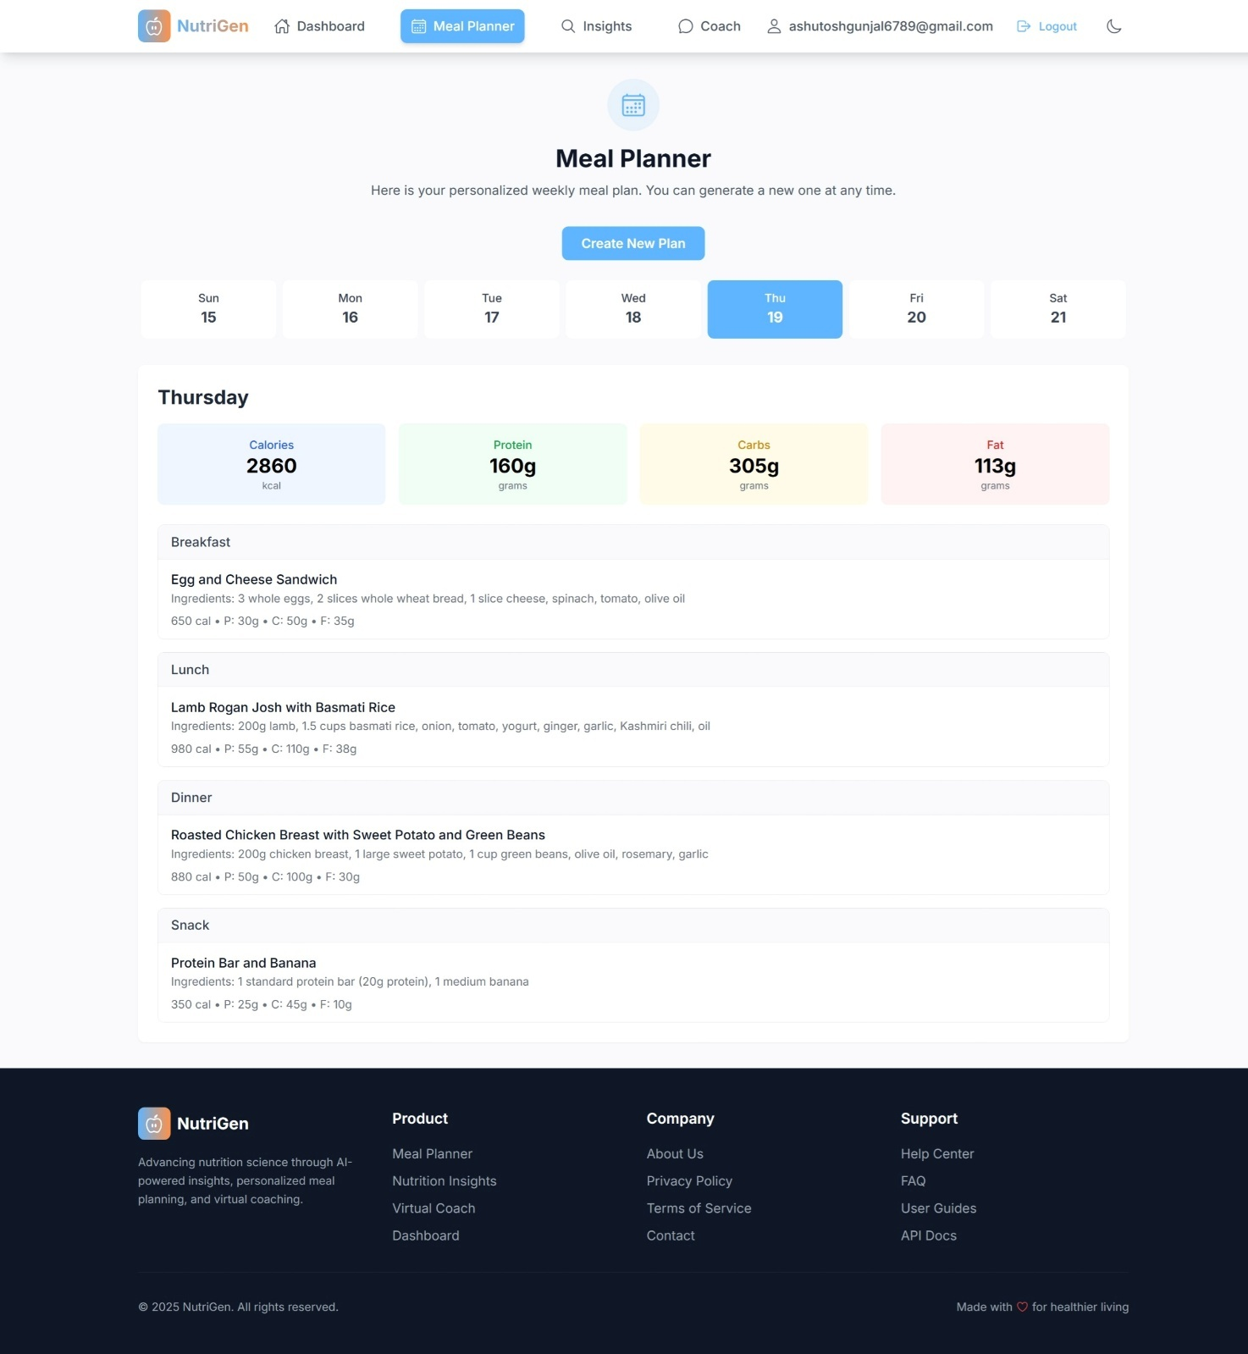

* **Virtual Coach Page:** This page presents a familiar chat interface with message bubbles for the user and the AI coach. It includes suggested prompts to help users start the conversation and supports voice input for hands-free interaction.

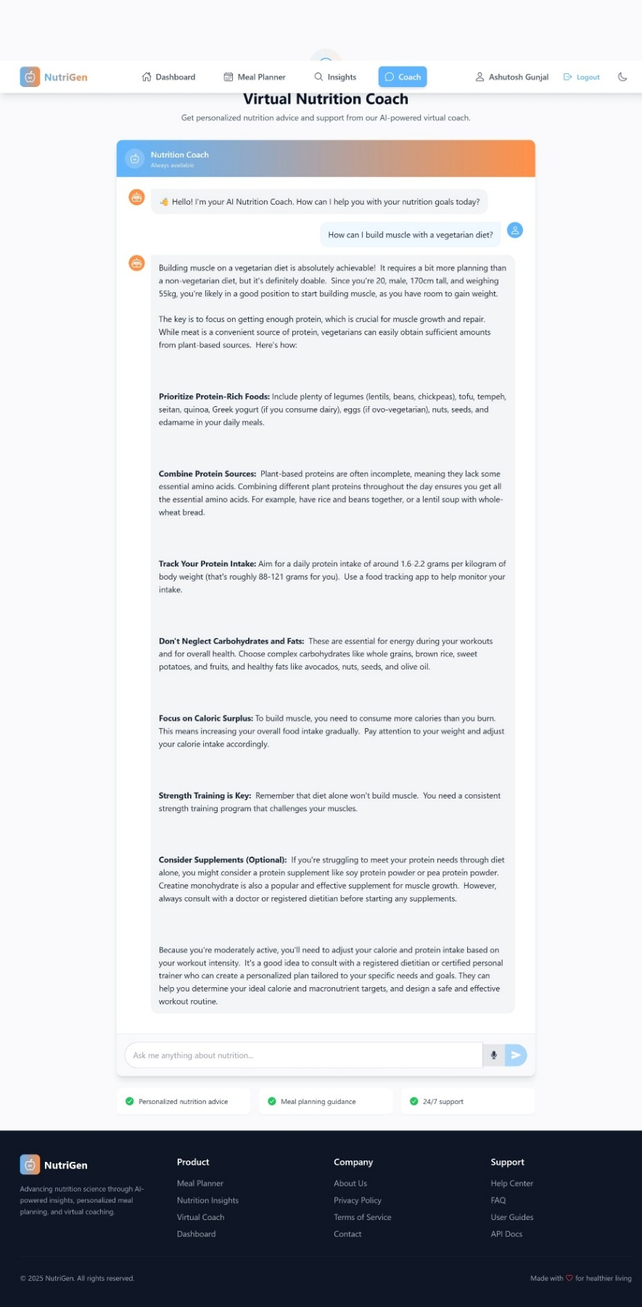

**20. Future Scope**

The current platform provides a strong foundation that can be extended with several high-impact features:

* **Mobile Application:** Develop a native or cross-platform (e.g., React Native) mobile app for on-the-go access to coaching and food logging.
* **Fitness Tracker Integration:** Integrate with APIs from Apple Health, Google Fit, and other fitness trackers to automatically sync activity levels, weight, and other health metrics, further enhancing personalization.
* **Image-to-Nutrition Analysis:** Allow users to take a photo of their meal, and use a computer vision model to identify the food items and estimate their nutritional content automatically.
* **Advanced Grocery List Management:** Enhance the grocery list feature with the ability to check off items, categorize them by store aisle, and integrate with online grocery delivery services.
* **Community and Social Features:** Introduce a community section where users can share their own healthy recipes, progress, and support one another, fostering a more engaging and supportive ecosystem.
* **Barcode Scanning:** Implement barcode scanning functionality in the mobile app to allow users to instantly retrieve nutritional information for packaged food products.

**21. Conclusion**

The NutriGen project successfully demonstrates the integration of a modern frontend stack (React, Redux) with a robust Python backend (Flask) to deliver a powerful, AI-driven health and nutrition platform. By leveraging Google's Generative AI, the application effectively addresses common challenges in personal nutrition management, offering highly personalized meal plans, on-demand nutritional insights, and accessible virtual coaching. The well-structured code, clear separation of concerns, and secure authentication mechanism provide a solid foundation for a scalable and user-centric product. NutriGen stands as a strong proof-of-concept for how AI can be practically applied to empower individuals in their journey toward better health.

**22. References**

1. Google Research. (2024, June 11). *Advancing personal health and wellness insights with AI*. Retrieved from https://research.google/blog/advancing-personal-health-and-wellness-insights-with-ai/
2. U.S. Department of Agriculture. (2024). *FoodData Central*. Retrieved from https://fdc.nal.usda.gov/
3. Firebase. (2024). *Firebase Authentication & Firestore documentation*. Retrieved from https://firebase.google.com/docs
4. Python Software Foundation. (2024). *Flask web development documentation*. Retrieved from https://flask.palletsprojects.com/
5. OpenAI. (2023). *Prompt engineering guide for large language models*. Retrieved from <https://platform.openai.com/docs/guides/prompt-engineering>
6. Google AI. (2024). *Gemini API overview and SDK*. Retrieved from <https://ai.google.dev/>
7. Jones, M., Bradley, J., & Sakimura, N. (2015). *JSON Web Token (JWT)*. Internet Engineering Task Force (IETF). Retrieved from https://jwt.io/introduction